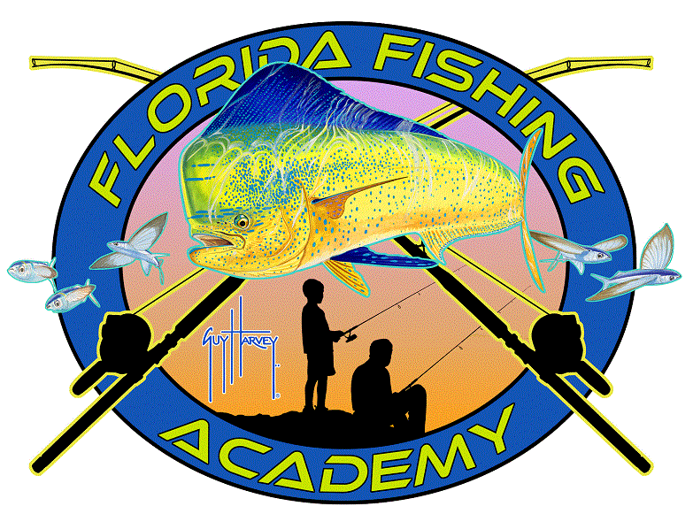
Florida Fishing Academy
Pollution 101 K-2

What is pollution?
Pollution: anything that makes the earth unhealthy and dirty
A Whale’s Tale: https://youtu.be/xFPoIU5iiYQ

There are lots of different kinds of pollution ranging for water, air, noise, light and more.

Examples of pollution include trash, food waste, cardboard boxes, plastic water bottles, lights, cars, cleaning supplies, fishing gear and more.

A few ways you can reduce pollution in your own home:

- Recycle- You can recycle waste like plastic and paper into a recycling bin
- Turn off the lights when you leave a room- this saves energy
- Reuse paper and use scrap paper
- Turn off the water when you are brushing your teeth- you can save almost 6 gallons or milk jugs of water per week
- Compost- Composting is when you take food waste and let it break down back into soil
- Skip the straw in your next beverage
- Get others to reduce their waste

We challenge you to reduce your waste this week! Share with us one way you plan on reducing your waste.
#reduceyouruse

___________________________________________________________________

___________________________________________________________________

___________________________________________________________________

This program is made possible with the support from Prime Time Palm Beach County, Inc., which receives significant funding for its overall operations from the Children’s Service Council of Palm Beach County. The Palm Beach County Youth Service Department provides support for Prime Time’s Middle School Out-of-School Time Initiative.
