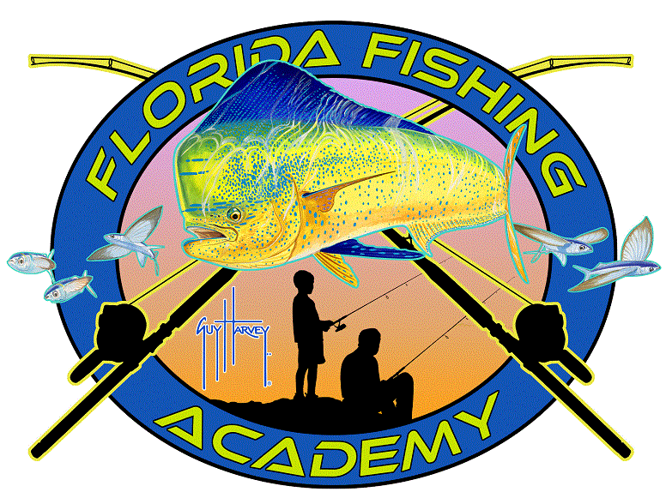
Florida Fishing Academy
Pollution 101 6-8

What is pollution?
Pollution: anything that’s introduced into the environment that has the potential to negatively influence the quality of life for humans, plants, or animals.

There are lots of different kinds of pollution: water, air, land, radioactive, thermal, noise, light and more.
Learn more about pollution here: https://www.youtube.com/watch?v=OqHp03RRTDs

Examples of pollution include trash, food waste, cardboard boxes, plastic water bottles, lights, cars, cleaning supplies, fishing gear and more.

A few ways you can reduce pollution in your own home:

- Recycle- You can recycle waste like plastic and paper into a recycling bin
- Turn off the lights when you leave a room- this saves energy
- Reuse paper and use scrap paper
- Turn off the water when you are brushing your teeth- you can save almost 6 gallons or milk jugs of water per week
- Compost- Composting is when you take food waste and let it break down back into soil
- Skip the straw in your next beverage
- Get others to reduce their waste

Often times our waste makes its way into the ocean which can harm sea animals.
How much plastic is in the Ocean? https://youtu.be/YFZS3Vh4lfI
Ocean Pollution Article: https://www.nrdc.org/stories/ocean-pollution-dirty-facts
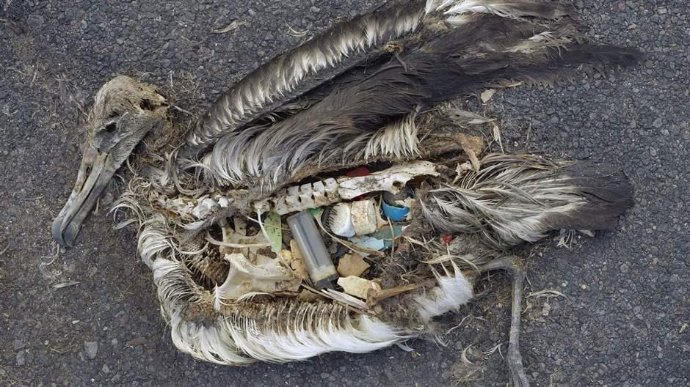
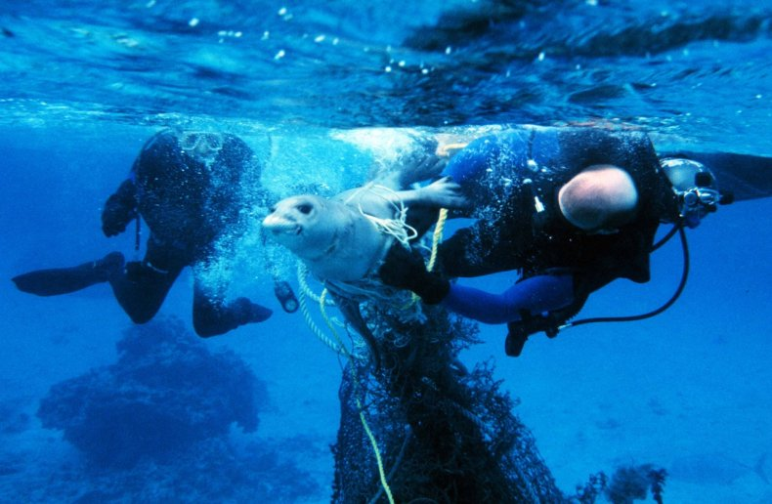
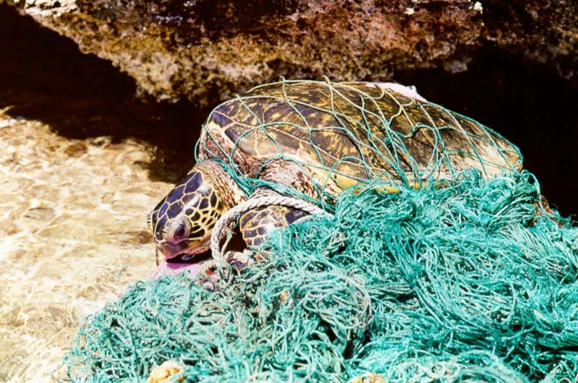
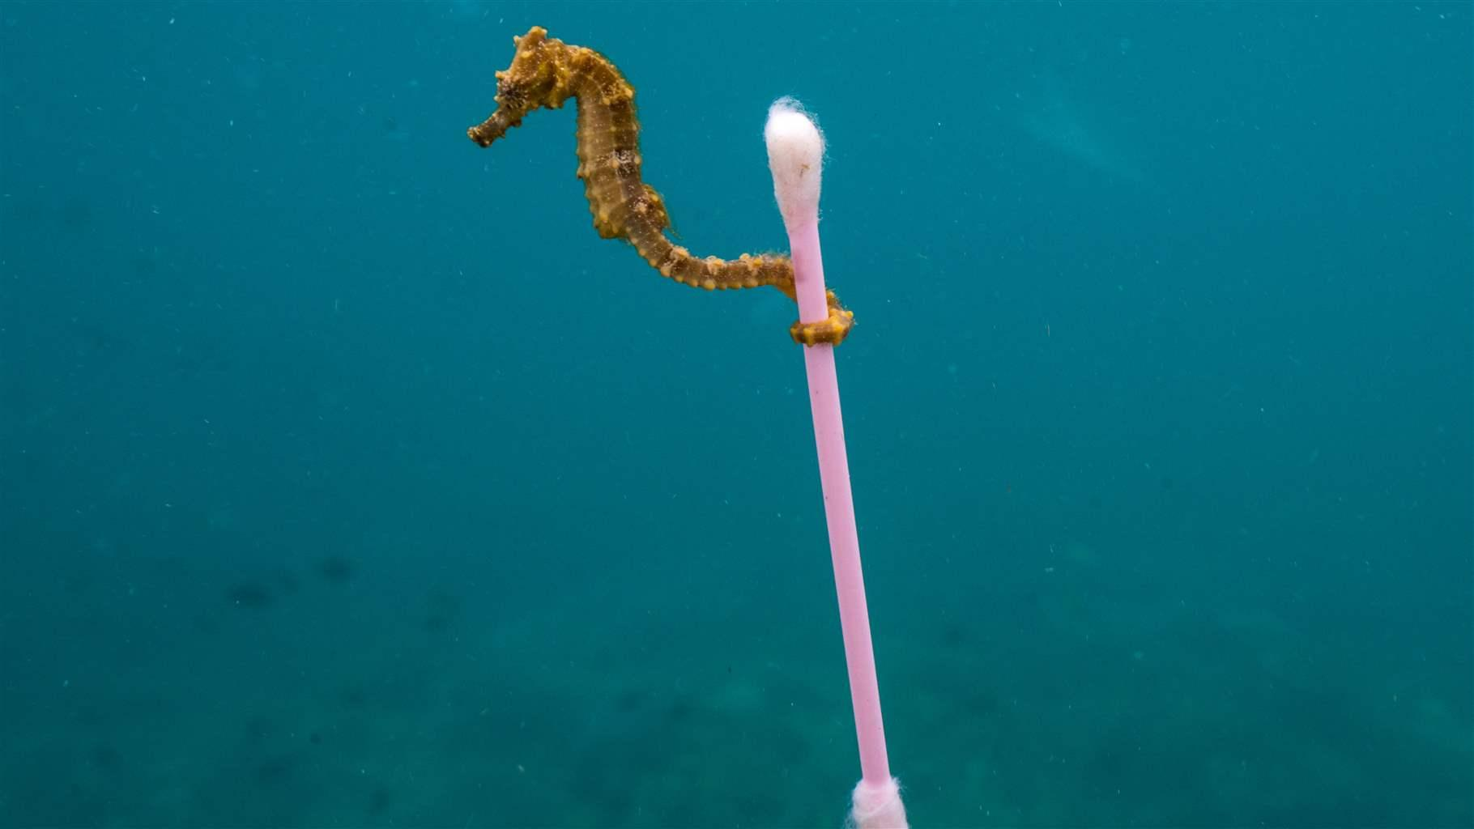

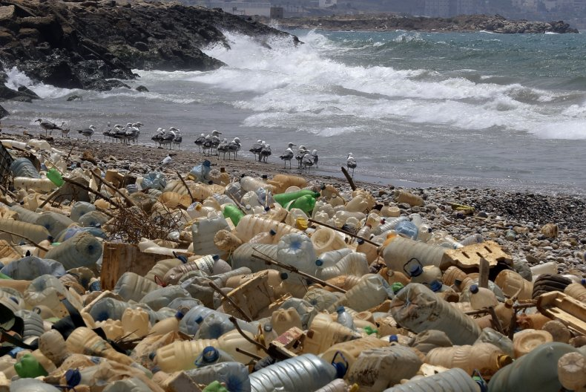
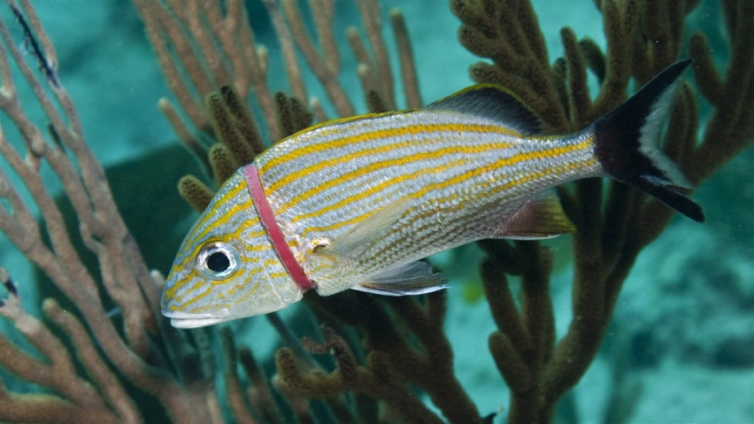

We challenge you to reduce your waste this week! Share with us one way you plan on reducing your waste.
#reduceyouruse

___________________________________________________________________

___________________________________________________________________

___________________________________________________________________

This program is made possible with the support from Prime Time Palm Beach County, Inc., which receives significant funding for its overall operations from the Children’s Service Council of Palm Beach County. The Palm Beach County Youth Service Department provides support for Prime Time’s Middle School Out-of-School Time Initiative.
